ANNEXURE - A

Name of Institute: Regional Ayurveda Research Institute, Port Blair
S.No. | Name | Designation | Contact No. | Email ID | Photo(If available)
1 | Dr. Abhayadev A | Research Officer (Ayu) | 09633180685 | abhayadev.a@gov.in | 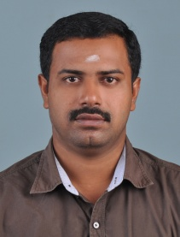
2 | Dr. Akashlal M | Research Officer (Ayu) | 09447755650 | akashlal.ccras@nic.in  akashlalm@gmail.com | 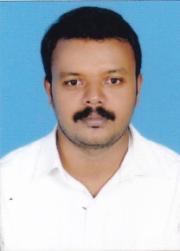
3 | Mr. Jishin Prakash T S | Research Assistant (Bot) | 08086722521 | jishinprakash.ccras@nic.in  jishinprakash@gmail.com | 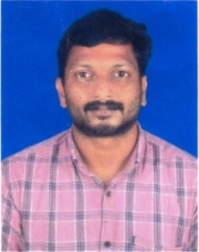

Research Officer In charge

