क्षेत्रीय आयुर्वेद अनुसंधान संस्थान
(केंद्रीय आयुर्वेदीय विज्ञान अनुसंधान परिषद्, आयुष मंत्रालय, भारत सरकार)
INS - 106, सेक्टर - 25, इन्दिरा नगर, लखनऊ-226016

संस्थान में कार्यरत स्थायी कर्मचारियों का विवरण

S.No | Employee Full Name/ Official Name | Designation of employee | Mobile No. | Email id | Photo
1 | Dr.Om Prakash | Assistant Director | 9406581637 | om.pra@ccras.nic.in | 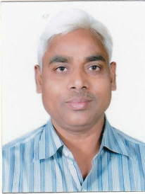
2 | Dr. Alok Kumar Srivastava | Research Officer, S-4 | 9792913313 | drakspatt@gmail.com | 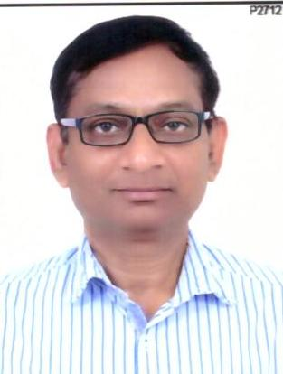
3 | Dr. Anjali Baijnath Prasad | Research Officer (Ay.) | 7737498848 | anjaliprasad75@gmail.com | 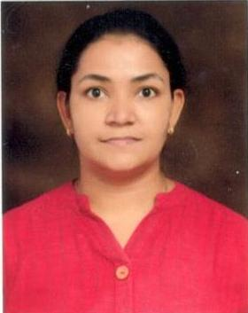
4 | Dr. Harit Kumari | Research Officer (Ay.) | 9837078947 | drharit79@gmail.com | 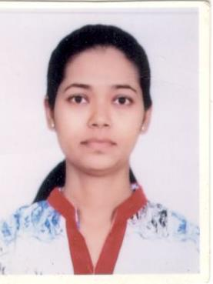
5 | Dr. Kamble Pallavi Namdev | Research Officer (Ay.) | 8955325835 | drpallavikamble24@gmail.com | 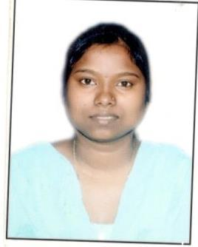
6 | Dr. Karishma Singh | Research Officer (Ay.) | 8368749544 | karishma@ccras.nic.in | 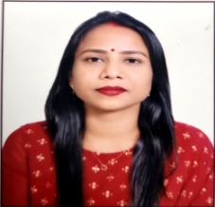
7 | Dr. Ravi Ranjan Singh | Research Officer (Path.) | 9911502825 | ravisingh_1@rediffmail.com | 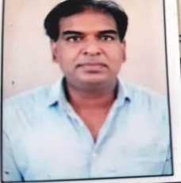
8 | Mamta Chaturvedi | Assistant | 9452272080 | mamta.c@ccras.nic.in | 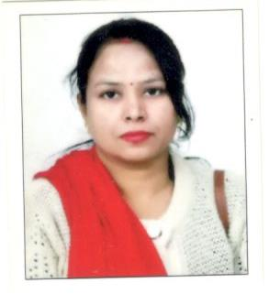
9 | Sachin Dwivedi | Staff Burse | 9479949497 | sachindwivedikhmc@gmail.com | 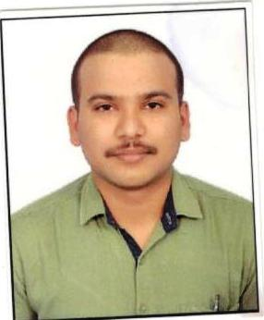
10 | Smita Singh | Social Worker | 9451870363 | smitarari24@gmail.com | 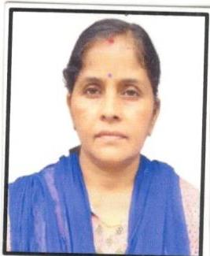
11 | Arjun Singh | Pharmacist | 7742588861 | jagararjun61@gmail.com | 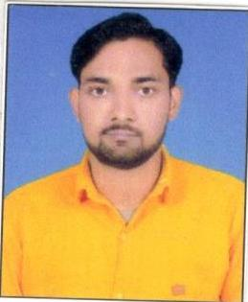
12 | Mukesh Kumar | Pharmacist | 8741869426 | mukeshku565@gmail.com | 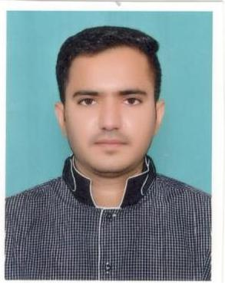
13 | Abinash Singh | Laboratory Technician | 7388559437 | avinashbaghel000007@gmail.com | 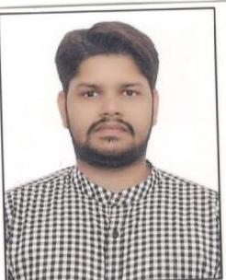
14 | Pradeep Kumar | Laboratory Assistant | 7355739602 | - | 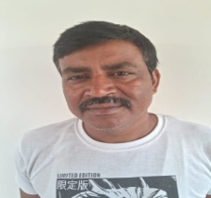
15 | Poonam | Lower Division Clerk | 8707496270 | pkm463630@gmail.com | 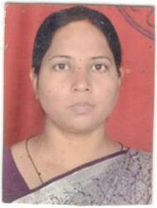
16 | Brijesh Kumar Rai | Lower Division Clerk | 9005395318 | brijeshraried@gmail.com | 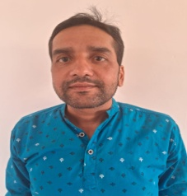
17 | Shivendra Sngh | Lower Division Clerk | 9005355250 | shivendra22aug@gmail.com | 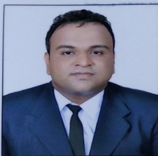
18 | Shiv Ashish | Laboratory Attendant | 9045941438 | shiv81880@gmail.com | 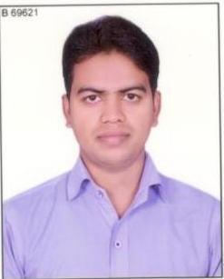
19 | Ratnesh Verma | Laboratory Attendant | 9557988860 | ratneshverma.smart@gmail.com | 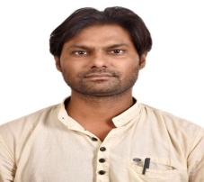
20 | Dheeraj Kumar Sen | MTS (Chowkidar) | 9453170454 | dheerajsen1108@gmail.com | 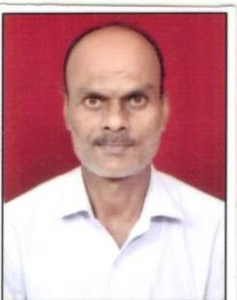
21 | Raj Kumar | MTS (Ward Boy) | 7380797010 |  | 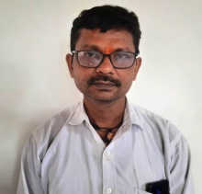
22 | Maya Rani | MTS (Chaprasi) | 8543039534 | - | 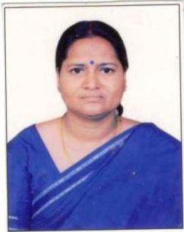
23 | Shashikala | MTS (Female Attendant) | 9616452157 | - | 