केन्द्रीय आयुर्वेद अनुसंधान संस्थान
Central Ayurveda Research Institute
केन्द्रीय आयुर्वेदीय विज्ञान अनुसंधान परिषद आयुष मंत्रालय ,भारत सरकार ,
CCRAS, Ministry of AYUSH, Government of India
4- सी. एन. ब्लॉक, सेक्टर- V, विधाननगर, कोलकाता – 700091
4- CN Block, Sector -V, Bidhannagar, Kolkata - 700091.

Fax: 033 2367-1001, EPBX : 033 2367-3881/1002, Ph. 033 2367-3808 (Director)
Email: nriadd-kolkata@gov.in & nriadd.kolkata@gmail.com

Personal details of all regular staff of this Institute

Sl. No. | Name | Designation | Contact | Email | Photo
 | Dr. G. Babu | Director | 8096455323 | drbabugajji@yahoo.com | 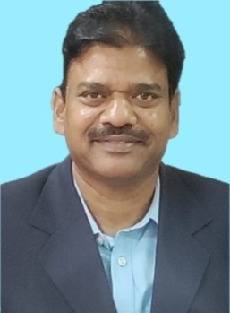
 | Dr. B.K. Sarkar | Assistant Director (Pharmacy) | 8427239267 | bireshsarkar@gmail.com
 | Dr. A.K. Mangal | Assistant Director (Pharmacognosy) | 8826210975 | anupam.mangal68@gmail.com | 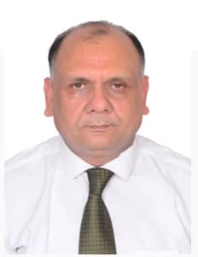
 | Dr. Amit Kumar Dixit | Assistant Director (Bio-Chemistry) | 8920574307 | deepdixit20@gmail.com | 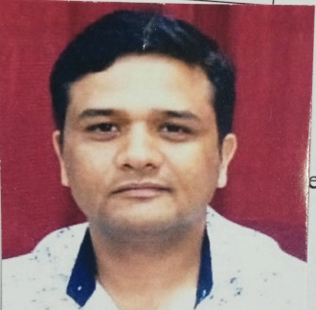
 | Dr. Sharad Daulatrao Pawar | Assistant Director (Pharmacology) | 8806166699 | sd.pawar@ccras.nic.in | 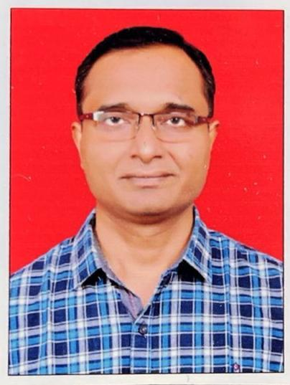
 | Dr. T. K. Mandal | Assistant Director (Ayurveda) | 9434737577 | drmandaltk@gmail.com | 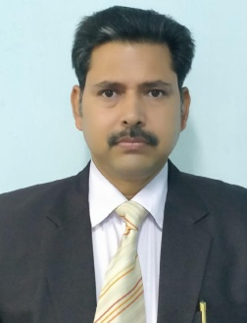
 | Dr. L. D. Barik | Research Officer (Ayurveda) | 8984282015 | ldbarik1963@gmail.com | 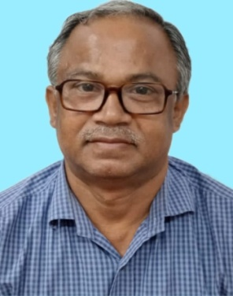
 | Dr. Dipsundar Sahu | Research Officer (Ayurveda) | 8895173999 | drdssahu@gmail.com | 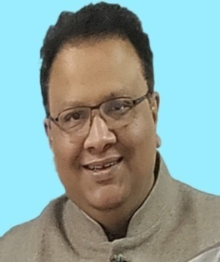
 | Dr. Debajyoti Das | Research Officer (Ayurveda) | 9836616647 | debajyoti.das02@gmail.com | 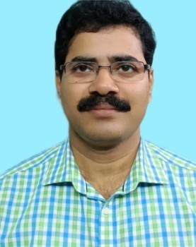
 | Dr. Saroj Kumar Debnath | Research Officer (Ayurveda) | 9477404010 | sarojkumardebnath@gmail.com | 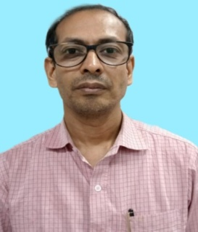
 | Mrs. Manosi Das | Research Officer (Chemistry) | 9831415035 | manosi_das@rediffmail.com | 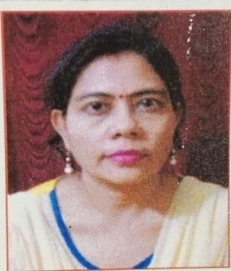
 | Mr. Kalyan Hazra | Research Officer (Chemistry) | 8902541030 | kalyan987@gmail.com | 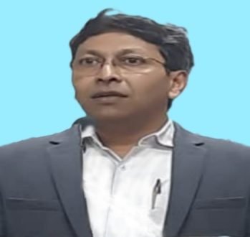
 | Dr. Rajesh Bolleddu | Research Officer (Pharmacognosy) | 9959714214 | rajesh_bolleddu@rediffmail.com | 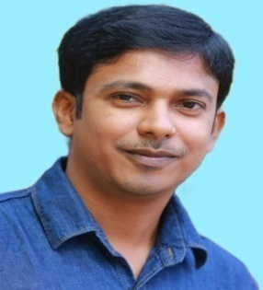
 | Dr. Ranjita Ekka | Research Officer (Ayurveda) | 7086510816 | drranjitaekka@gmail.com | 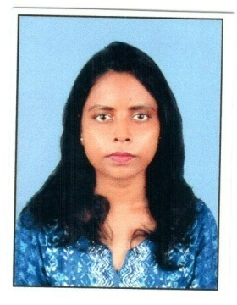
 | Dr. Hetalben Amin | Research Officer (Ayurveda) | 9924194660 | dr.hetal1985@gmail.com | 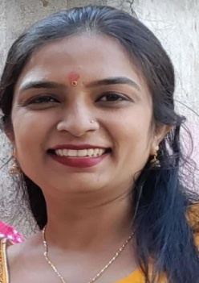
 | Dr. Lalrinpuia | Research Officer (Pharmacology) | 9123336774 | kawlni.rinpuia@gmail.com | 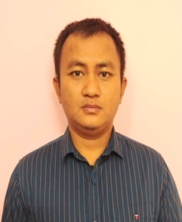
 | Smt. Sreya Dutta | Research Officer (Botany) | 8902411209 | mailtosreya.27@gmail.com | 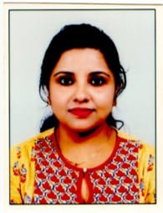
 | Dr. Suparna Saha | Research Officer (Ayurveda) | 8637836206 | sahajewel638@gmail.com | 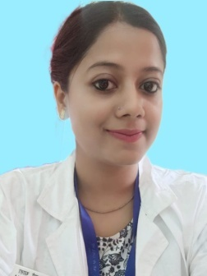
 | Dr. Susmita Roy | Research officer (Microbiology) | 7003027846 | roy740@gmail.com | 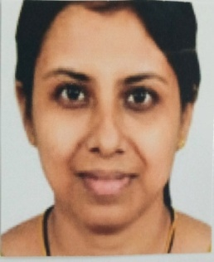
 | Dr. Shakti Bhushan | Research Officer (Ayurveda) | 9670867205 | shakti.imsbhu@gmail.com | 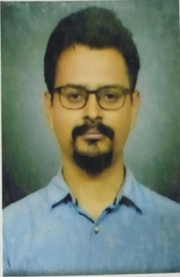
 | Dr. Deepak Kumar | Research Officer (Chemistry) | 9785580925 | dpkjangid89@gmail.com | 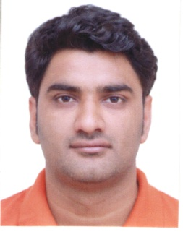
 | Dr. Rahul Singh | Research Officer (AEP/Pharmacology) | 9453907815 | drrahul.singh1987@gmail.com | 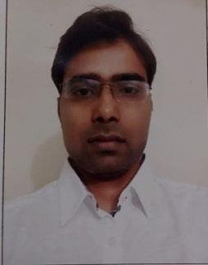
 | Ms. Jyoti Dahiya | Assistant Research Officer (Pharmacognosy) | 9876917262 | jyotidahiya31@gmail.com | 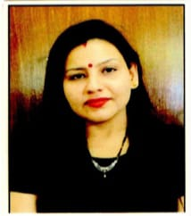
 | Mr. Qadir Alam | Assistant Research Officer (Pharmacology) | 9451071910 | qadir.alam786@gmail.com | 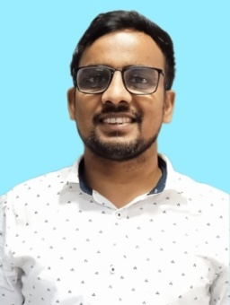
 | Mr. Manoj Batule | Assistant Research Officer (Chemistry) | 9850334121 | manojbatule99@gmail.com | 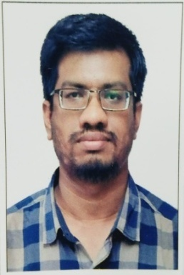
 | Dr. Malayamarutham Kalyankumarraju | Assistant Research Officer (Pharmacology) | 8240862753 | mkalyankumarraju@gmail.com | 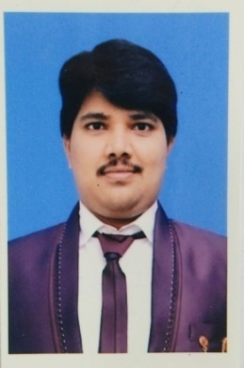
 | Dr. Sudipto Debnath | Research Assistant (Chemistry) | 8902338785 | debnath1304@gmail.com | 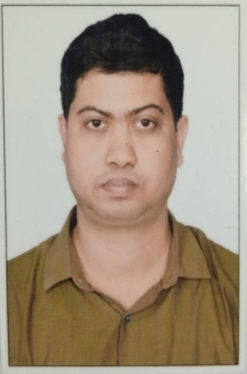
 | Dr. Susmita Mondal | Research Assistant (Chemistry) | 9547895490 | mondal.susmita2000@gmail.com | 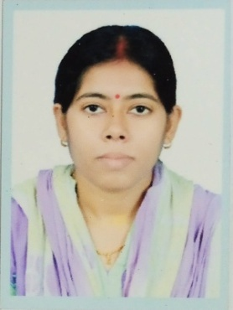
 | Mr. Ranjit Kumar Dey | Research Assistant (Chemistry) | 9830804029 | ranjitdey82@gmail.com | 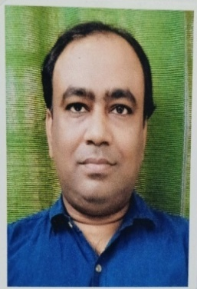
 | Mr. Parth Ramesh Gharat | Research Assistant (Pharmacy) | 9607038237 | parth.gharat32@gmail.com | 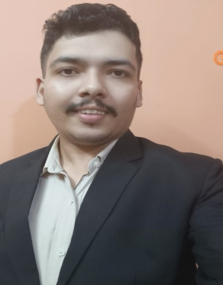
 | Ms. Simmi Mall | Research Assistant (Botany) | 7302119083 | simmimall2022@gmail.com | 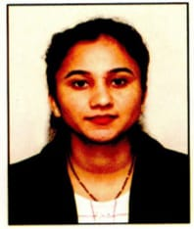
 | Ms. Piu Ghosh | Sister In-charge | 9775649279 | meetpiu2010@gmail.com | 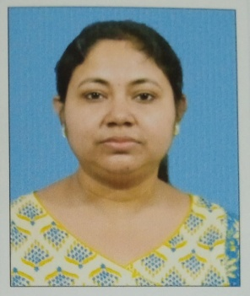
 | Ms. Baisakhi Chakraborty | Staff Nurse | 7076948084 | shibbabaplusbaisakhi@gmail.com | 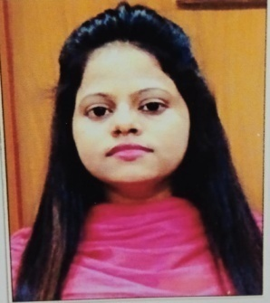
 | Ms. Madhumita Ash | Staff Nurse | 8001002099 | madhumitaash10@gmail.com | 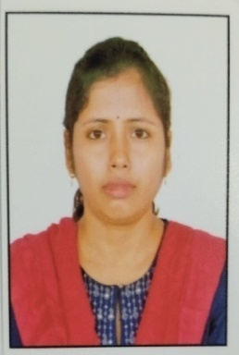
 | Ms. Sima Hutait | Staff Nurse | 6291332267 | simahutait005@gmail.com | 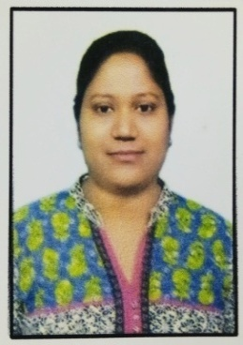
 | Mr. Dilip Singh Purviya | Staff Nurse | 8963808478 | dilip.singh907@gmail.com | 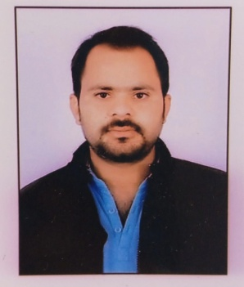
 | Mr. Naveen Singh Dindorya | Staff Nurse | 9509950745 | nik0076081@gmail.com | 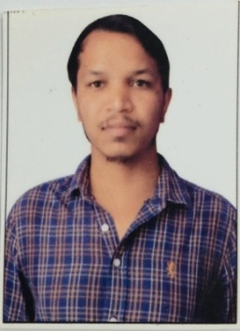
 | Mr. Sandip Dalui | Pharmacist | 9836999097 | sandip.dalui02@gmail.com | 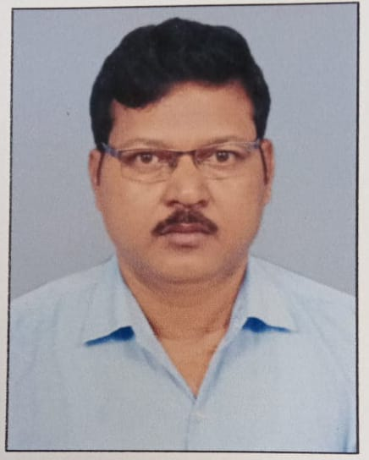
 | Mr. Debdas Rana | Pharmacist | 9874059745 | debdasrana@gmail.com | 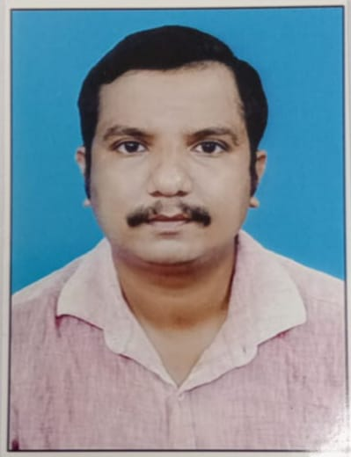
 | Mr.Abdul Jabbar | Pharmacist | 9143129195 | jabbarnri@gmail.com | 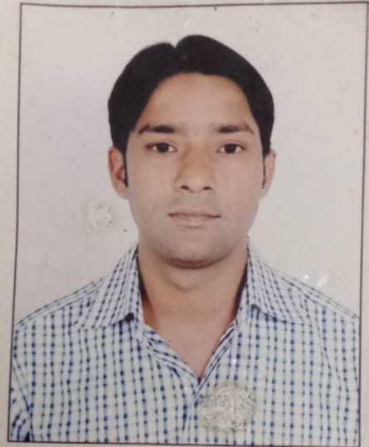
 | Mrs. Suchandra Mandal | Pharmacist | 7381370753 | tina8suchandra@gmail.com | 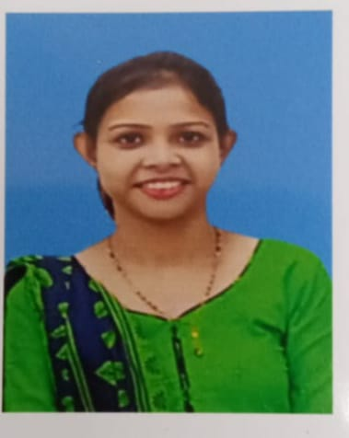
 | Mr. Biplab Ganguly | Lab. Tech. | 9433022209 | biplab_gan@rediffmail.com | 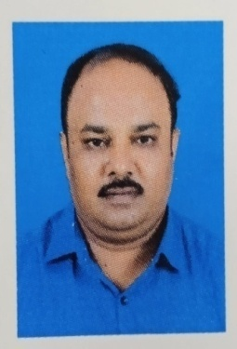
 | Mr. Utpal Hazra | Lab. Tech. | 9477026395 | utpalhazr@gmail.com | 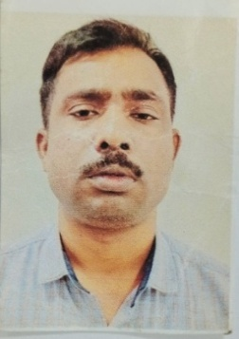
 | Mr. Subhas Chandra Pandey | Lab. Tech. | 9432122033 | scpandey789@gmail.com | 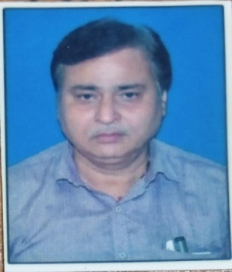
 | Mr. Pappu Kumar | Upper Division Clerk | 9693161013 | kumarpappu262012@gmail.com | 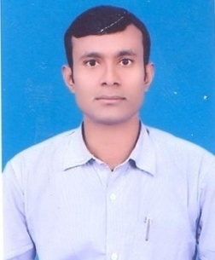
 | Mr. Raja Haldar | Dark Room Assistant | 9836536799 | raja.haldar@gov.in | 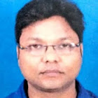
 | Smt. Archana Rakshit | Lower Division Clerk | 7908120711 | mailmearchanarakshit@gmail.com | 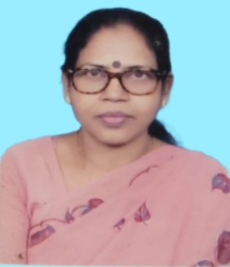
 | Mr. Amit Patra | Lower Division Clerk | 7584059940 | amitpatra200694@gmail.com | 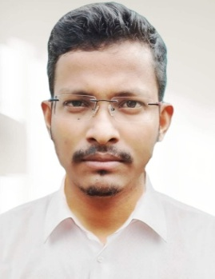
 | Mr. Ankit Kumar | Lower Division Clerk | 9905690918 | ankitkrndu@gmail.com | 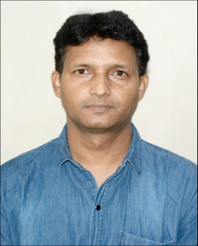
 | Mr. Magaram Hazra | MTS | 9432182132 | hazramagaram@gmail.com | 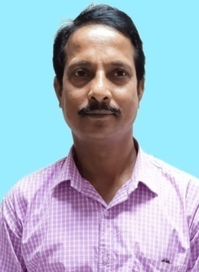
 | Mr. Virendra Kumar | MTS | 8981392458 | kumartakeu@gmail.com | 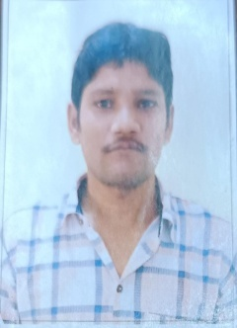
 | Mrs. Mina Kumari | MTS | 8481013227 | ansul.chowdhary@gmail.com | 