CENTRAL AYURVEDA RESEARCH INSTITUTE, JHANSI

S. No. | Name | Designation | Contact No. | Email ID | Photo  (If available)
1 | Dr. Ch. Venkata Narasimhaji | Assistant Director In-charge | 9566139022 | vnjicheemalapati@gmail.com | 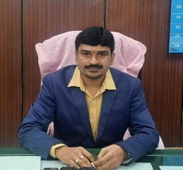
2 | Dr. Sanjeev Kumar Lale, RO (Ayu.) | RO (Ay.) | 9532930669 | drslale@gmail.com | 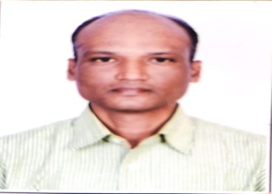
3 | Dr. Usha Kirand | RO (Botany) | 9452258708 | dr.ushakiranro@gmail.com | 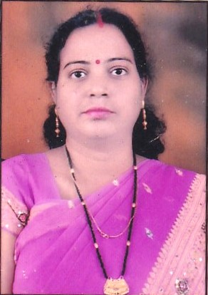
4 | Dr. J.C. Arya | RO (Botany) | 8859851417 | aryakunal2010@gmail.com | 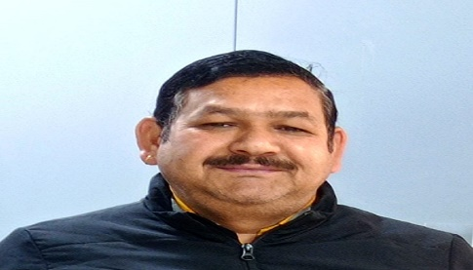
5 | Dr. Shyam Babu Prashad | RO (P’cognosy) | 9518904276 | shyamprasad@ccras.nic.in | 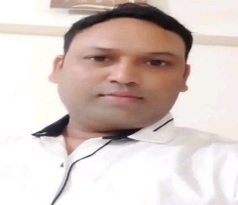
6 | Dr. Vijay Kumar | RO (Chemistry) | 9888897250 | vijaychem99@gmail.com | 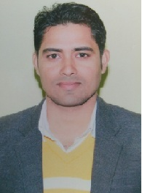
7 | Dr. Chandrashekhar Jagtap | RO (Ay.) | 9725519408 | drshikhar84@gmail.com | 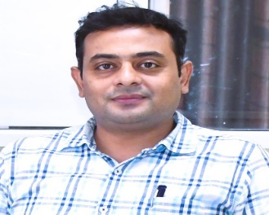
8 | Dr. Vaibhav Charde | RO (Ay.) | 8208080996 | vaibhavayudoc@gmail.com | 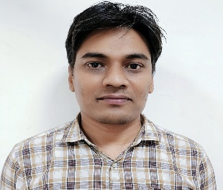
9 | Dr. Deepa Sharma | RO (Ay.) | 9450109125 | sha.dpa@gmail.com | 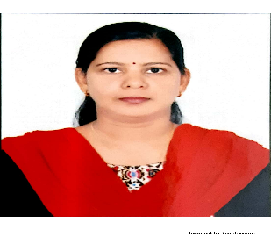
10 | Dr. Singh Neelam Kumari Mahesh | RO (Ay.) | 9891260758 | drsengar.neelam@gmail.com | 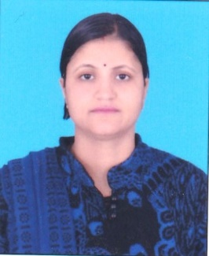
11 | Dr. Sujeet Kumar Mishra | RO (Chemistry) | 9540775358 | sujeetmishra5@yahoo.com | 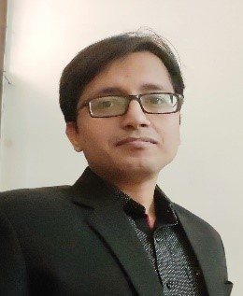
12 | Dr. Smriti Tondon | RO (Microbiology) | 9999870791 | smrititandon1991@gmail.com | 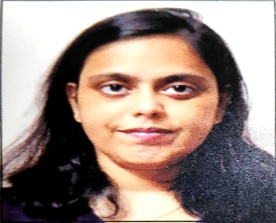
13 | Dr. Hemant Soni | RO (Microbiology) | 8989661540 | hemant.ash@gmail.com | 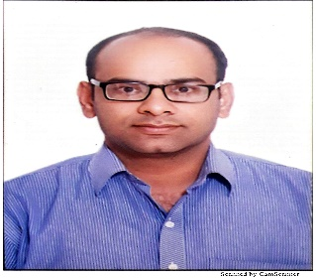
14 | Shri Ravi Chandra | RO (Botany) | 9450093094 | ravi0987chandra@gmail.com | 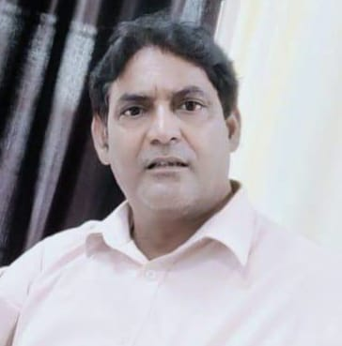
15 | Miss Akansha Thakur | ARO (P'cognosy) | 8488040110 | takansha698@gmail.com | 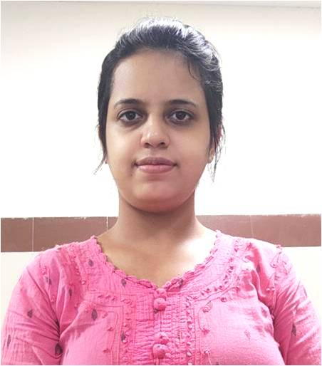
16 | Mr. Gagandeep Singh | ARO (Microbiology) | 8285477478 | gagan.sk.1994@gmail.com | 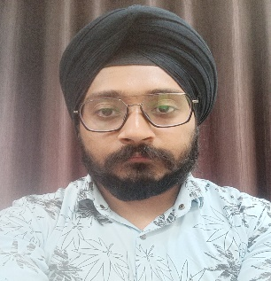
17 | Mr. Hemant Rawat | ARO (Chemistry) | 8506857320 | hemantrawat0712@gmail.com | 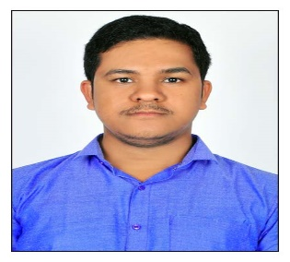
18 | Shri Arvind Kumar | Assitant | 9717012656 | arvindkumar4978@gmail.com | 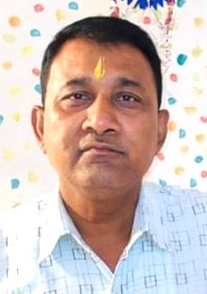
19 | Miss Yashika Gandhi | RA (Chemistry) | 9971767740 | yashika.gandhi1996@gmail.com | 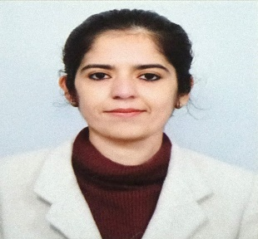
20 | Miss Jyotika | RA (Chemistry) | 6239831623 | jyotika14grewal@gmail.com | 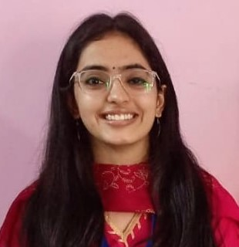
21 | Dr. Vipin Kumar Jain | RA (Chemistry) | 7754916091 | jain91vipin@gmail.com | 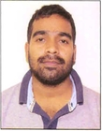
22 | Mr. Santosh Kumar Shakya | RA (Chemistry) | 9653776984 | santoshdehalwar@gmail.com | 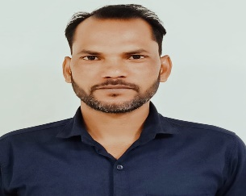
23 | Miss Charul Anand | RA (Botany) | 8079062740 | charulanand95@gmail.com | 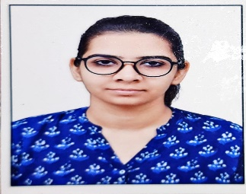
24 | Dr. Younas Rasheed Tantray | RA (Botany) | 7780960762 | younasrasheed53@gmail.com | 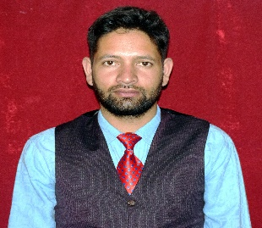
25 | Miss Preeti Gorla | RA (Curator) | 9711149280 | preetigorla@yahoo.in | 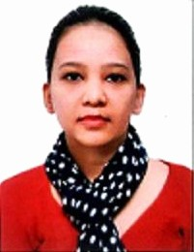
26 | Mr. Ganesh Dane | RA (Pharmacy) | 9762205807 | ganeshddane@gmail.com | 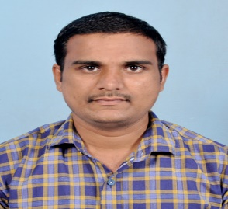
27 | Mr. Kishan Singh | RA (Pharmacy) | 9627634850 | bisht.kspharmaceutics@gmail.com | 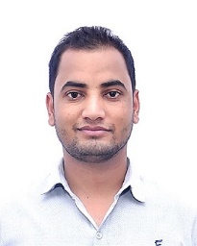
28 | Mr. Virendra Singh | RA (Garden) | 8107735657 | virukolsiya174@gmail.com | 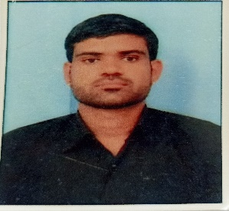
29 | Mr. Santosh Saket | MTS | 7905727993 | santoshsaket5722@gmail.com | 