Regional Ayurveda Research Institute, Itanagar

Regular staff (Officials/Officers) working at peripheral institutes of CCRAS

Sl. | Name | Designation | Contact No. | Email ID | Photo (If available)
 | Dr. Sudhanshu Kumar Meher | Research Officer (Ayurveda) Incharge | 9178009633 | sudhanshu@ccras.nic.in,  drmeher@rediffmail.com | 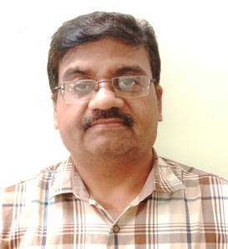
 | Dr. Arvind Kumar | Research Officer (Ayurveda) | 9660033435 | dr.arvindaggarwal@gmail.com | 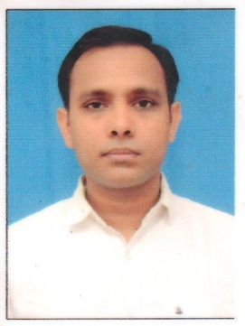
 | Dr. Vishnu Vardhan Narayanam | Research Officer (Ayurveda) | 8125467773 | vardhanbams@gmail.com | 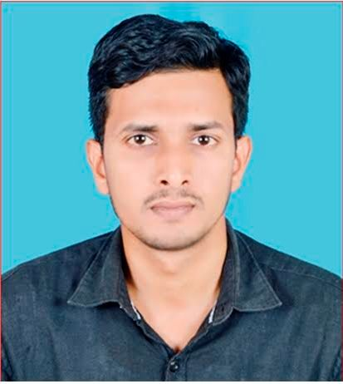
 | Dr. Yashpal Bhardwaj | ARO (Bot.) | 9305410894 | yashpalbot.bhu@gmail.com | 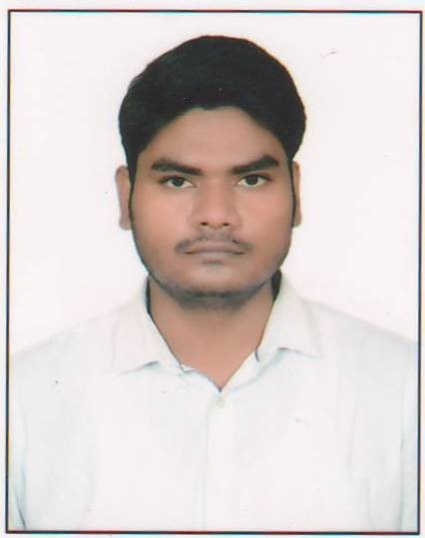
 | Mrs. Nani Yadi | Sister-in-charge | 8787601046 | naniyadi2022@gmail.com | 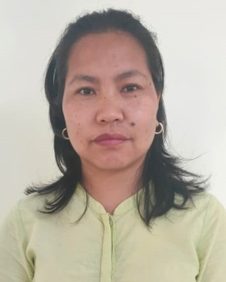
 | Dr. C. Srinivasulu | Research Assistant (Botany) | 9963853349 | srenubio@gmail.com | 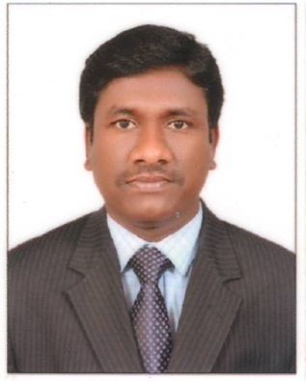
 | Dr. Yugandhar Pulicherla, | Research Assistant (Garden) | 9618434539 | yugandharbotany@gmail.com | 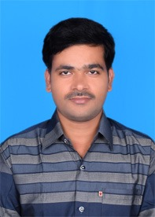
 | Sh. Mrinal Das | Lab. Technician | 9485236354 | dasm34285@gmail.com | 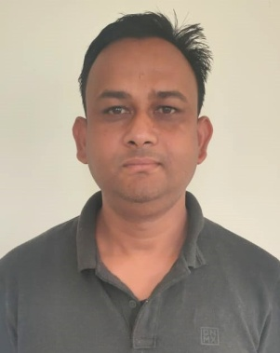
 | Mr. S.K. Sudhanshu | Sr. Pharmacist Gr.-II  (Diploma Holder) | 7005304210 | sksudhanshu26@gmail.com | 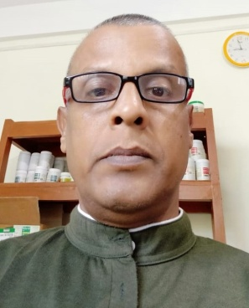
 | Sh. Vijay Kumar | Assistant | 9709383537 | k.vijay@ccras.nic.in | 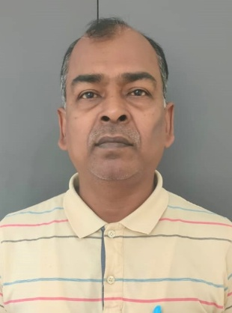
 | Sh. U.C. Kardong | Lab. Attendant | 9436254119 | Umeshkardong8@gmail.com | 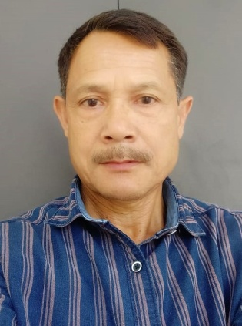
 | Sh. Vinay Singh | LDC | 8787461418 | vinay2791994@gmail.com | 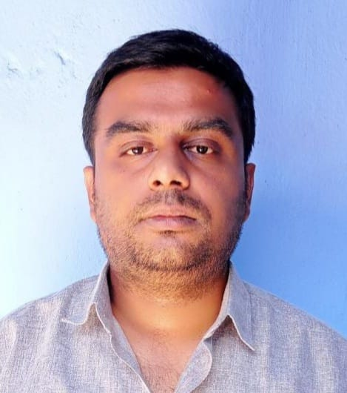
 | Sh. Tagom Riyang | Field Attendant | 9436636429 | NA | 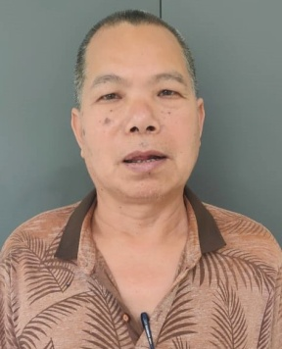
 | Sh. Druva Jyoti Payeng | Field Attendant | 9402898875 | payengdhruvajyoti@gmail.com | 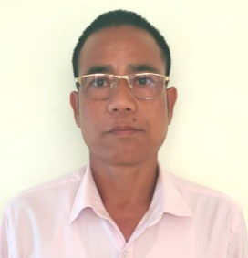
 | Miss Yadam Taga | Ward Aya | 9436898730 | NA | 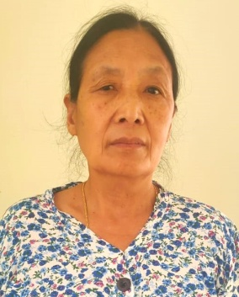
 | Mrs. Pura Pane | Peon | 9856549572 | NA | 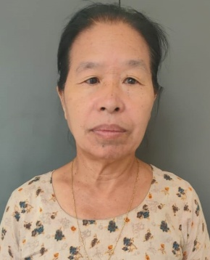
 | Mrs. Hage Remang | Peon | 8014203655 | NA | 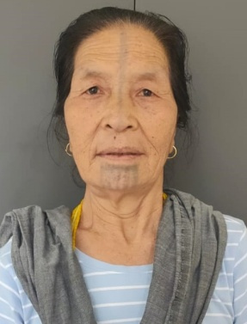
 | Mrs. Okyam Padung | Peon | 7085399010 | NA | 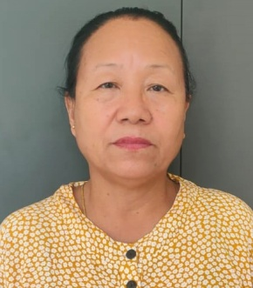
 | Mrs. Budh Kumari Pradhan | Peon | 9402736510 | budhkumaripradhan@gmail.com | 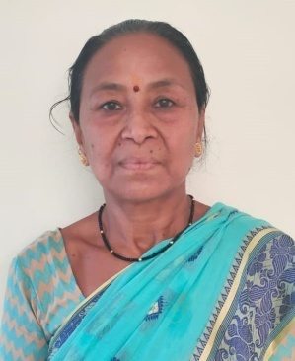
 | Sh. Jogesh Boruah | Safaiwala | 9402401734 | NA | 