NATIONAL INSTITUTE OF INDIAN MEDICAL HERITAGE, HYDERABAD

S. No. | Name | Designation | Contact No. | Email ID | Photo(If available)
 | Dr. Goli Penchala Prasad | Assistant Director In-charge | 9441654500 | goli.prasad@gov.in drprasadgoli@yahoo.com | 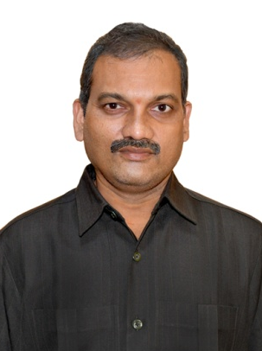
 | Dr. V. Sridevi | Research Officer (Ay.) | 9491634415 | venigalla.sd@ccras.nic.in sridevivenigalla@gmail.com | 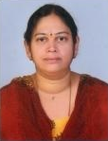
 | Dr. Ashfaque Ahmad | Research Officer (Unani) | 9700034608 | ashfaq.ahmad70@gov.in rounaniccras@gmail.com | 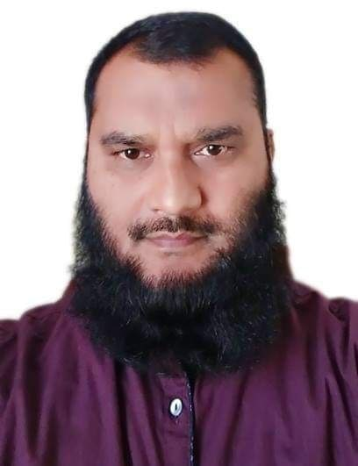
 | Dr. T. Saketh Ram | Research Officer (Ay.) | 9849995719 | dr.saketram@gmail.com  saketram.74@gov.in | 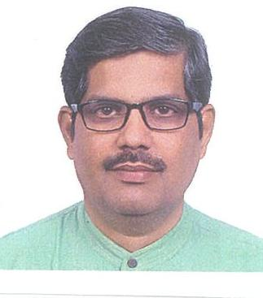
 | Dr. Santosh S Mane | Research Officer (Ay.) | 9531830002 | s.santosh@ccras.nic.in  vdmaheshmane@gmail.com | 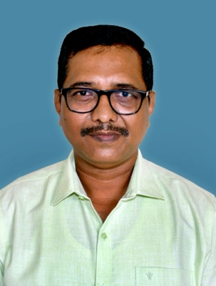
 | Dr. Biswo Ranjan Das | Research Officer (Homoeo.) | 8247801631 | bisworanjan.80@gov.in bisworanjan.das00@gmail.com | 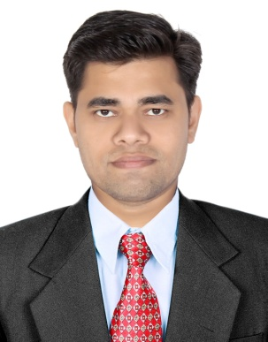
 | Dr. Chris Antony | Research Officer (Ay.) | 7807773464 | chrisantony1@gmail.com | 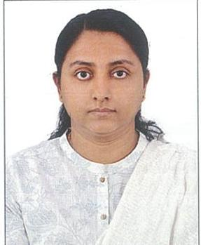
 | Shri P. Murali Manohar | ARO (Curator) | 9959013648 | penta.manohar@ccras.nic.in manoharosmania@gmail.com | 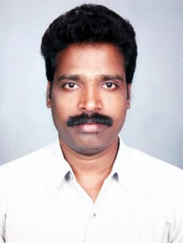
 | Shri K. Priyavrat Reddy | Assistant | 9666673666 | kotha.reddy@ccras.nic.in kpreddy74@gmail.com | 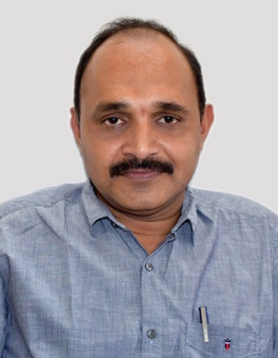
 | Shri K. Srinivasa Rao | Library & Info. Asst. | 9441273178 | srinivas.koppisetty@gov.in koppisett99@gmail.com | 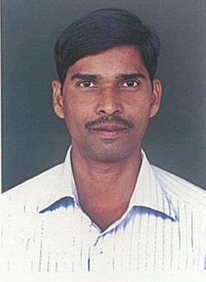
 | Shri G. Ravi Babu | Photographer | 8328042709 | gubbala.babu@ccras.nic.in  grbabu31@gmail.com | 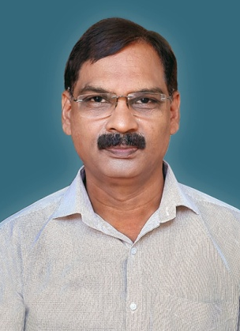
 | Ms. Varsha Kumari | Library & Info. Asst. | 6304639240 | varsha.k@ccras.nic.in varshasinghtomar92@gmail.com | 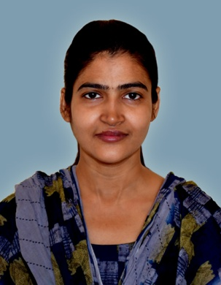
 | Dr. Satyabrata Nanda | Reserach Assistant (Sanskrit) | 8019507660 | satyabrata.n@ccras.nic.in meetsatyabrata@gmail.com | 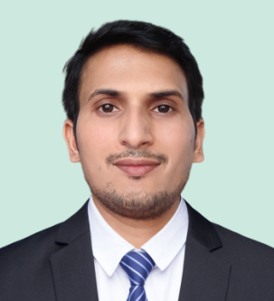
 | Shri G.Madhusudan Reddy | Staff Car Driver, Gr-I | 9490217892 | gurram.reddy@ccras.nic.in gmsreddy3@gmail.com | 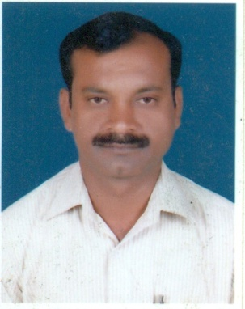
 | Shri B. Vijay Kumar | Sr. Library Attendant | 9440090897 | bashakarlavijay@gmail.com | 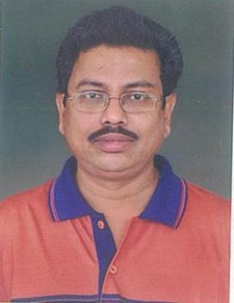
 | Shri B. Rama Rao | MTS | 9701511644 | ramub.1990@gov.in ramubandla9908@gmail.com | 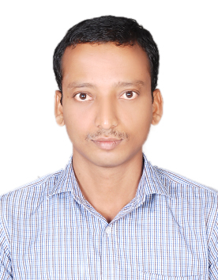
 | Shri T. Sekhar | MTS | 9390400178 | tallashekhar1997@gmail.com | 