REGIONAL AYURVEDA RESEARCH INSTITUTE, AHMEDABAD

S. No. | Name | Designation | Contact No. | Email ID | Photo (If available)
 | Dr. Kiran Vinayak Kale | Assistant Director (Ay.) I/c | 98907 46684 | kalekiran2004@yahoo.co.in | 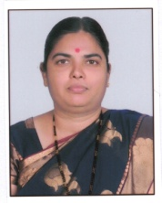
 | Vd. Jaiprakash Ram | Research Officer (Ay.) | 77918 34211 | jpram.vd@ccras.nic.in  jpram236@gmail.com | 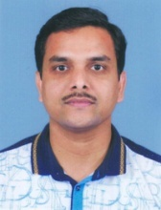
 | Dr. Parth Prakashbhai Dave | Research Officer (Ay.) | 96389 48973 | parth.dave@gov.in drppdave88@gmail.com | 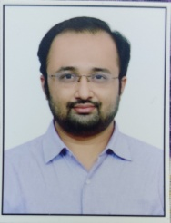
 | Dr. Anil Damodar Avhad | Research Officer (Ay.) | 95101 76085 | dranil.avhad@gov.in anilavhad4u@yahoo.com | 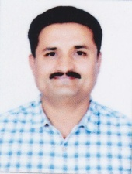
 | Dr. Paikrao Sumed Narayanrao | Research Officer (Ay.) | 76988 25705 | drsumed.paikrao@gov.in sampaikrao27@gmail.com | 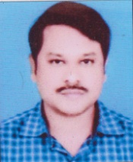
 | Dr. Suprabha K. | Research Officer (Ay.) | 91643 87950 | suprabha.k@ccras.nic.in sprbhk@gmail.com | 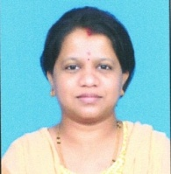
 | Sh. Balavant Kumar | Staff Nurse | 80030 34914 | balavantkumar07@gmail.com | 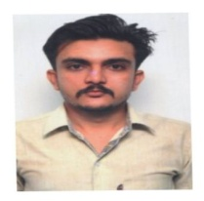
 | Sh. H.R. Parmar | Assistant | 98921 57782 | phimmat92@gmail.com | 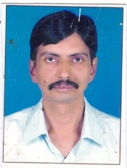
 | Sh. Diptesh Nanavati | MLT | 99044 52120 | diptesh.p@ccras.nic.in dipteshparmardp@gmail.com | 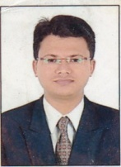
 | Smt. Hiralben Bechara | Pharmacist | 99628 43417 | becharahiral421@gmail.com | 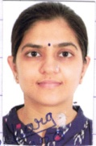
 | Sheetalba Sarvaiya, | Laboratory Technician | 83477 01026  99090 00507 | sheetal.sarvaiya@gov.in sheetal.jadeja25390@gmail.com | 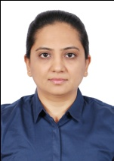
 | Smt. Padmaben Y. Shrimali | Laboratory Technician | 96627 69146 | padma4family@gmail.com | 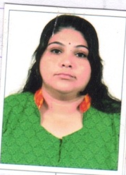
 | Sh. Ankit | LDC | 83079 24988 | a8529240761@gmail.com | 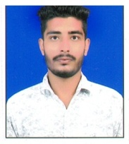
 | Sh. Dharmendrakumar Thakur | Laboratory Attendant | 78708 75913 | tk.dharmendra@ccras.nic.in dharmendrakumarth491@gmail.com | 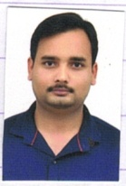
 | Smt. Kanchan Mahavar | Laboratory Attendant | 83471 28022 | kanchan.mahavar@gov.in kanchan.ipr@gmail.com | 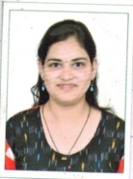
 | Sh. R.M. Dhatura | Attendant | 82387 59862 | r.dhatura@ccras.nic.in rdhatura@gmail.com | 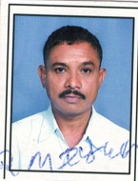
 | Sh. J.G. Chauhan | Field Attendant | 99793 84740 | jayantigchauhan0068@gmail.com | 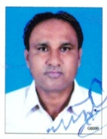
 | Sh. N.M. Garchar | Survey Attendant | 98797 14657 | galchar661@gmail.com | 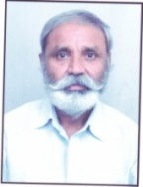
 | Sh. R.J. Bhupta | MTS | 98794 23848 | rajesh.bhupta@ccras.nic.in rajeshbhupta1970@gmail.com | 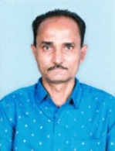
 | Sh. D.M. Galiyal | MTS | 96389 71135 | dineshgaliyal107@gmail.com | 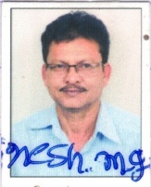
 | Sh. G.P. Acharya | MTS | 99092 30471 | g.pacharya18@ccras.nic.in gpacharya18@gmail.com | 